**Largest sum contiguous sub array**

rite an efficient program to find the sum of contiguous subarray within a one-dimensional array of numbers which has the largest sum.

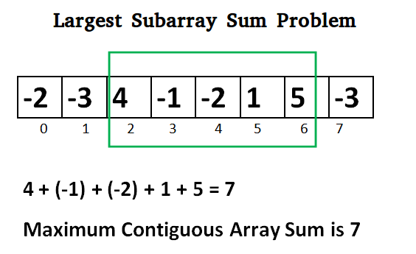

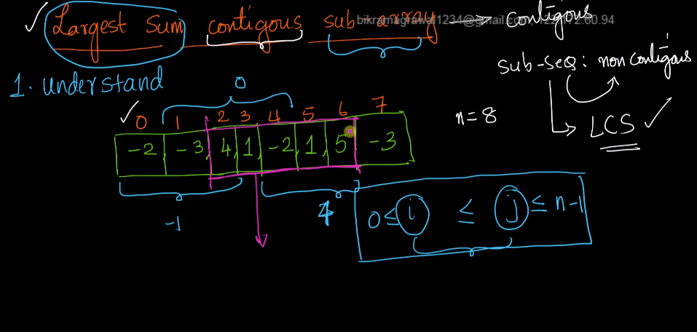

Brute force approach:-

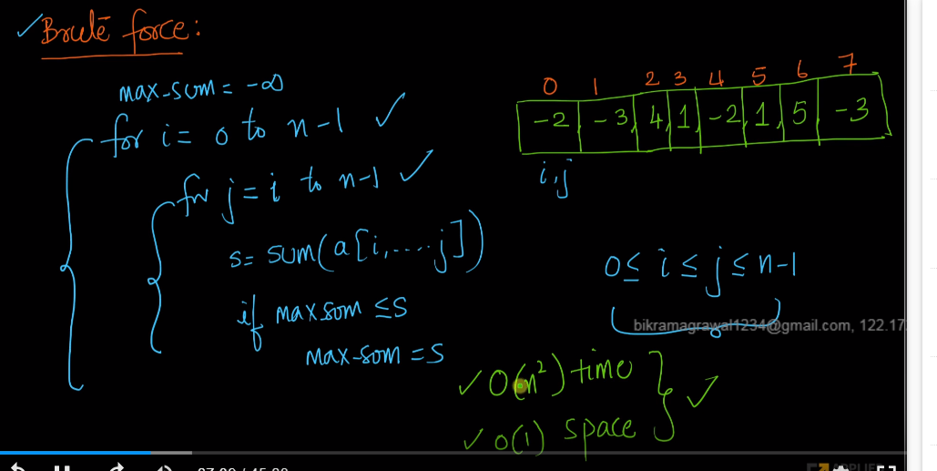

Time complexity is O(n2) which is terrible.

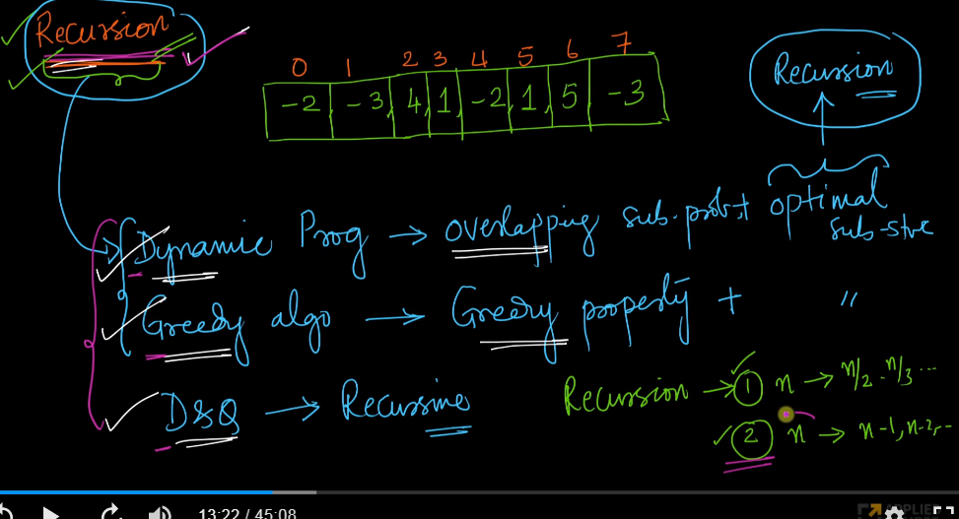

In recursion, we always divide the data into n/2,n/3,n/4 like this or n-1,n-2,n-3 like this.

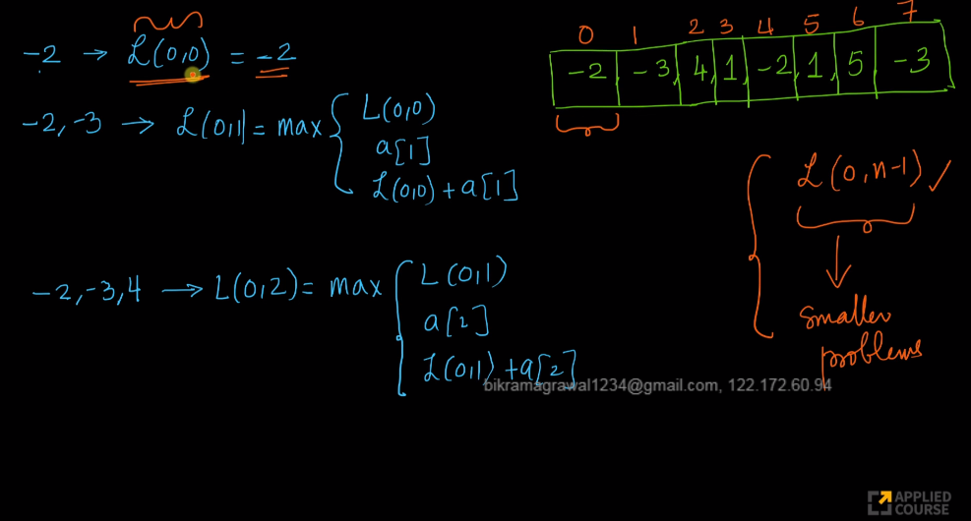

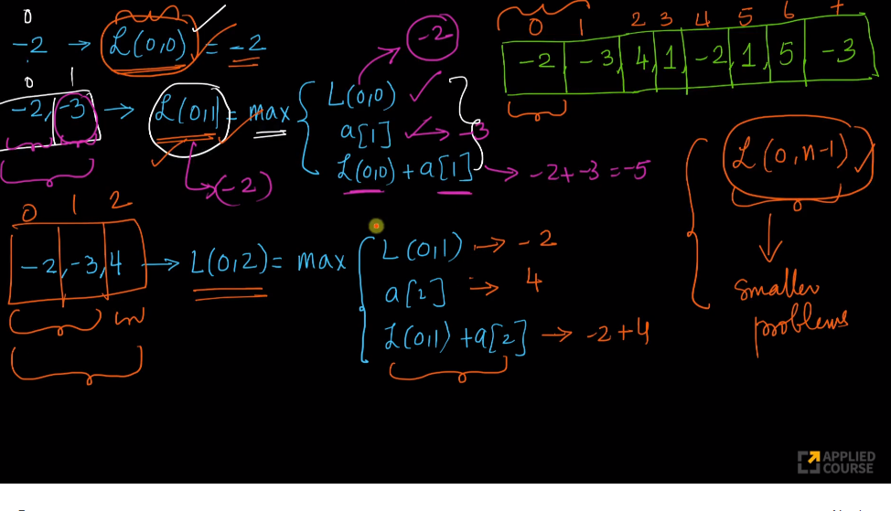

Here in the third statement we are adding -2+4 which is not contigous. because -2 is a[0] and 4 is a[2].But we need contigous subarray.

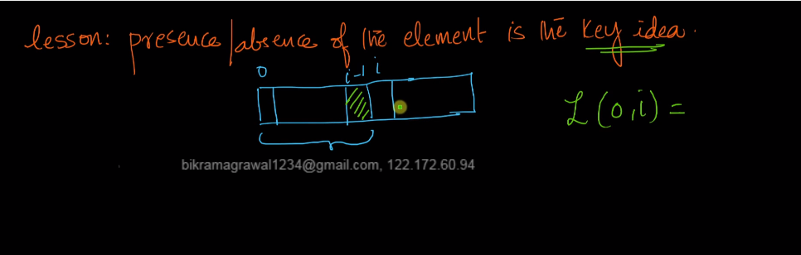

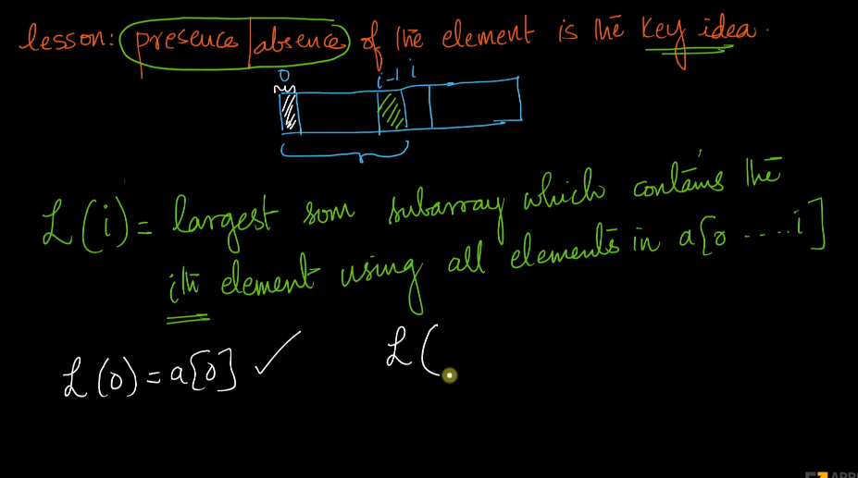

Now we are redefingn the solution as largest sum subarray should contain the element . For Exmaple L(i) should contain ith element where L(i) is the solution of the problem.

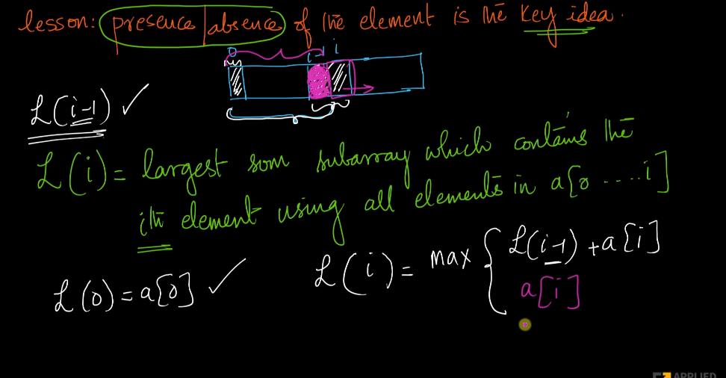

Here we are takking L(i-1) which is sum till (i-1)th element. So we will check if adding the current number a[i] will be the largest sum or we will start from a[i]. Either of this should be the largest sum till ith element of the array.

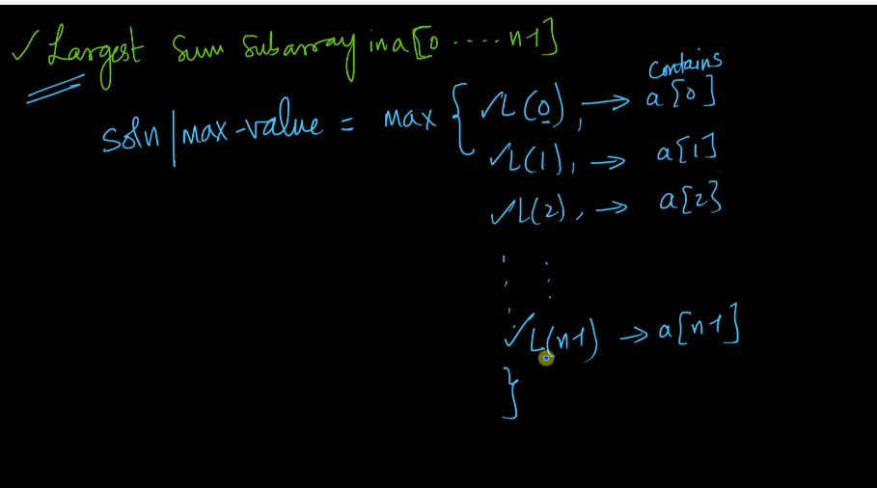

Here we are considering the maximum sum subarray. L[0] means maximum sub array containing a[0], L(1) is the maxium sum subaaray containing a[1]. Here we dont want this. We want the maximum sub array among every sum so that we wil get maximum sum subaaray.

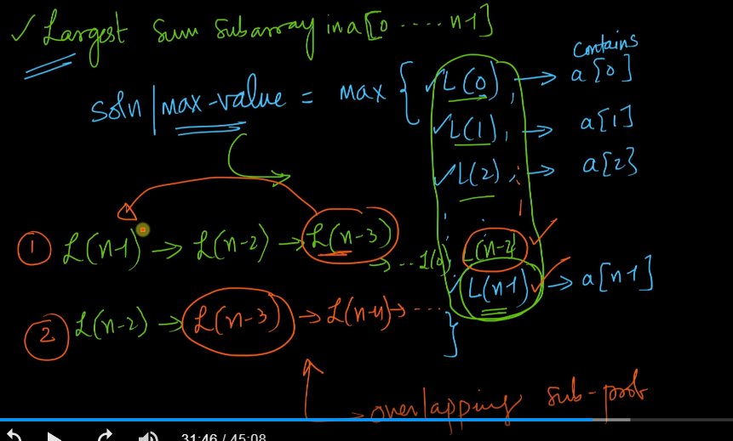

Here in point 1 and 2, we can see that there is overlapping sub problem. because in L(n-1), we compute L(n-2). to compute L(n-2), we compute L(n-3) like this.

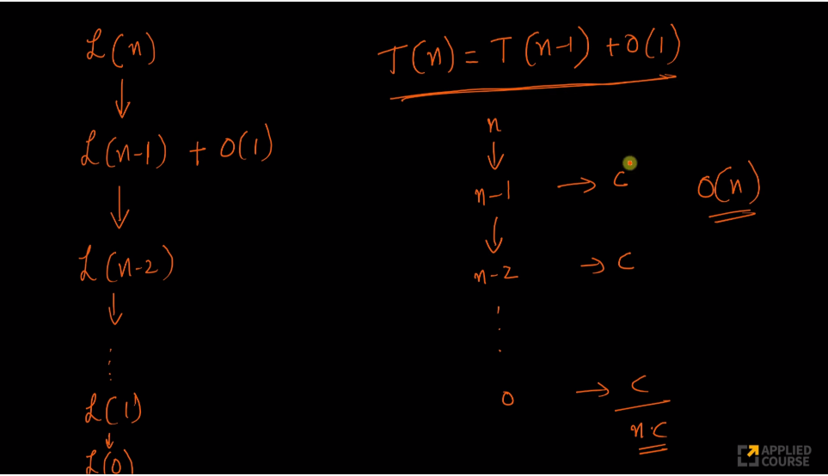

To compute the recursive relation, above the time complexity.

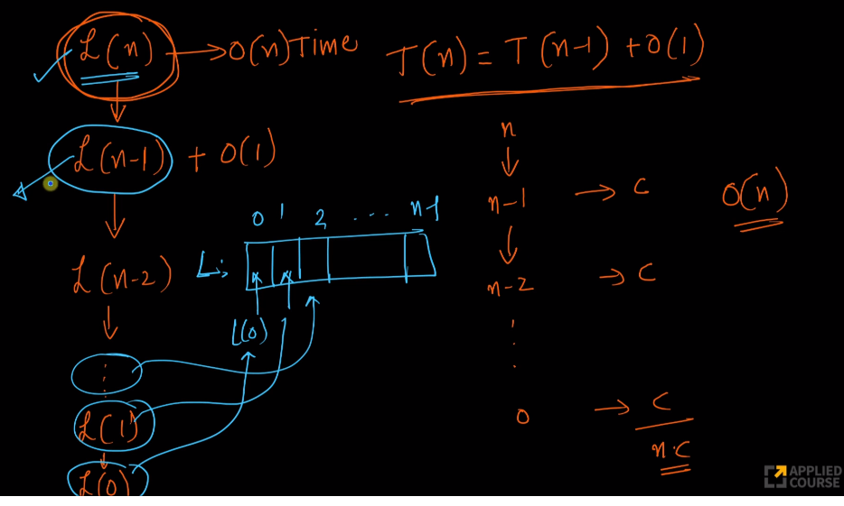

here we can create an array and store the results which can be used later on which is called memonization.

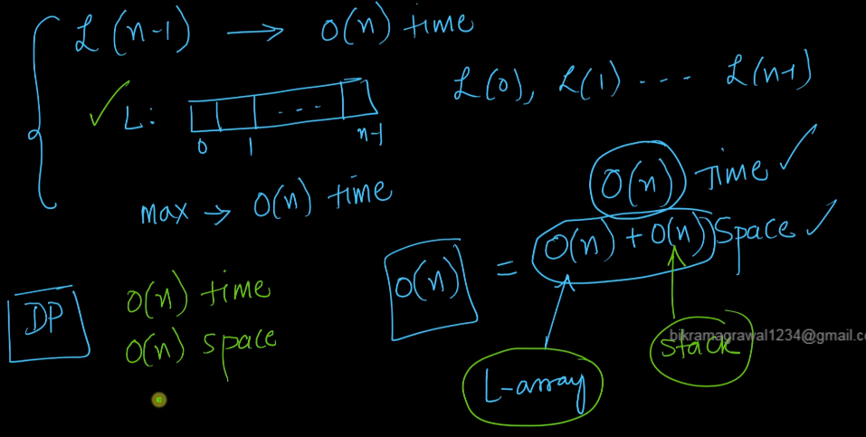

Here we have two types of space. One is store the intermediate result and another one is the stack space which is also 0(n).

This is standard example of Dynamic programming.

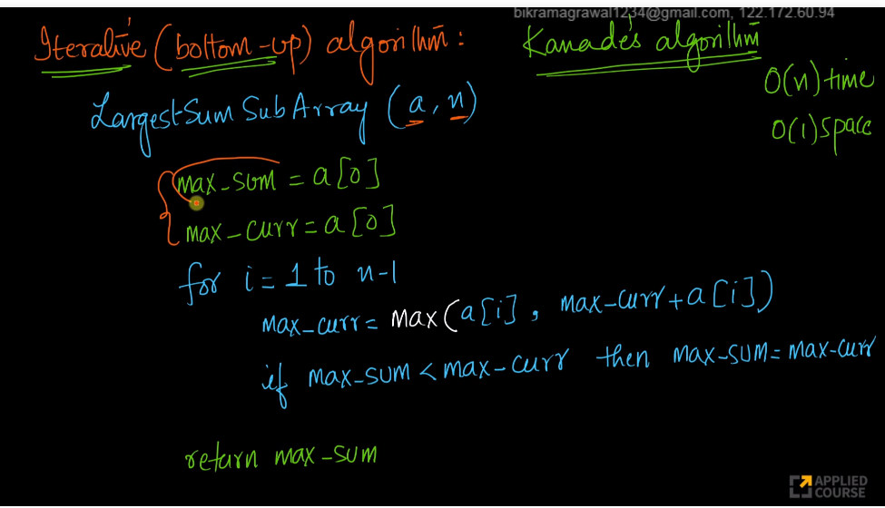

Here we converting this into a iteration and only taking 0(1) sub array.

Max_sum is our result. This is the maximum sum among all the subarray.

Max_curr is the maximum sum subarray which inculudes the current element.

def maxSubArraySum(a,size):

    max_so_far =a[0]

    curr_max = a[0]

    for i in range(1,size):

        curr_max = max(a[i], curr_max + a[i])

        max_so_far = max(max_so_far,curr_max)

    return max_so_far

# Driver function to check the above function

a = [-2, -3, 4, -1, -2, 1, 5, -3]

print"Maximum contiguous sum is" , maxSubArraySum(a,len(a))

# Longest Palindromic sub sequence

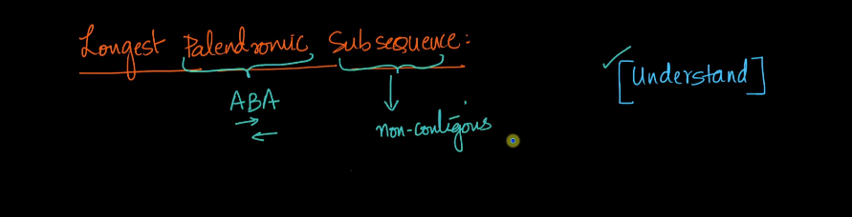

Subsequence is not contigous.

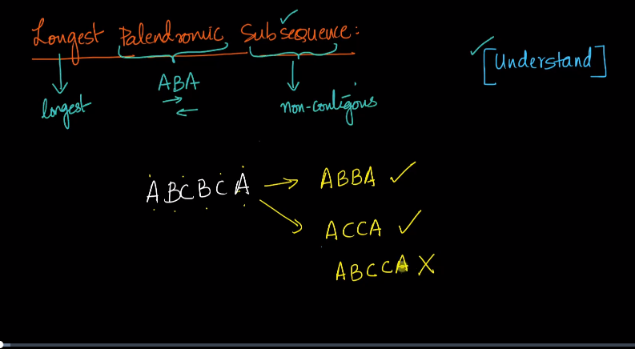

Here we have two subsequnce . We need to take the maximum length among all the palidondromic subsequnce.

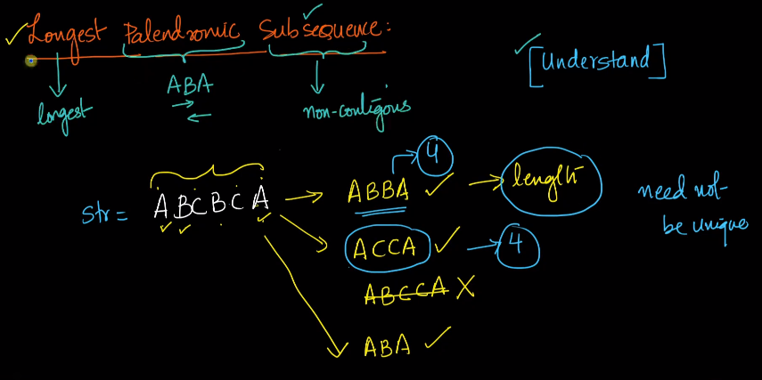

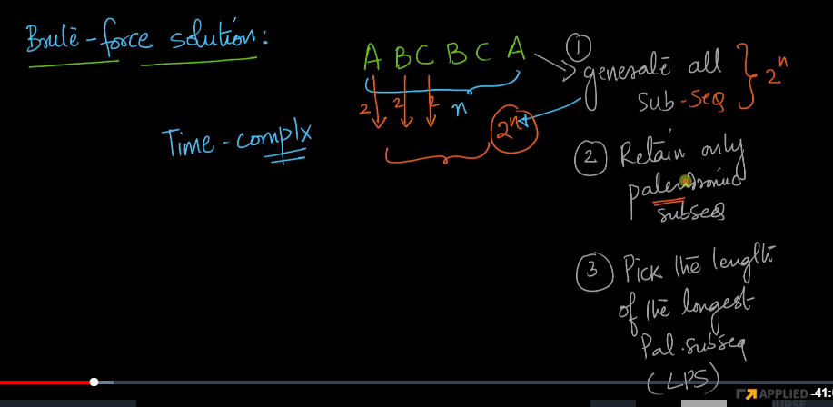

In brute force approach, we can take the element or discard the element .So it is 0(2). If we consider all the element it is going to be 0(2 power n).

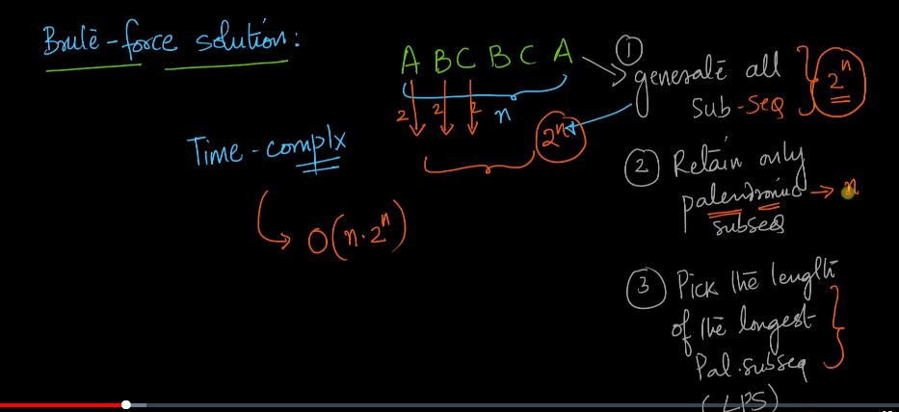

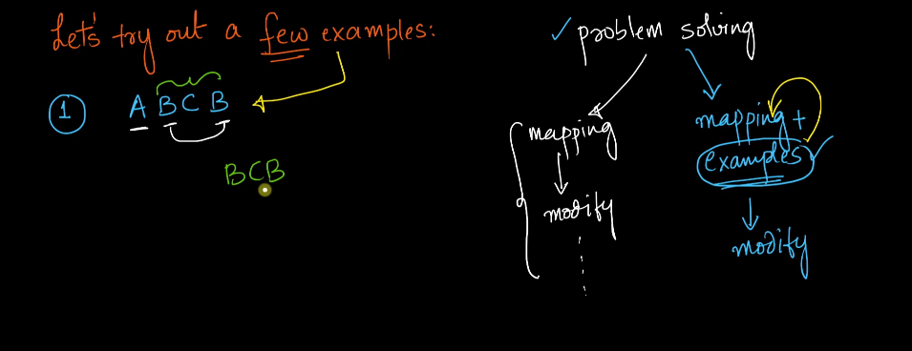

here we will go through some examples. Here we can remove the first element and check if it is palindrome or not.

Because we have odd number of character.

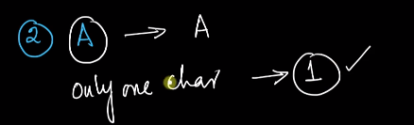

If we have only one character , the length of longest palindrome is 1.

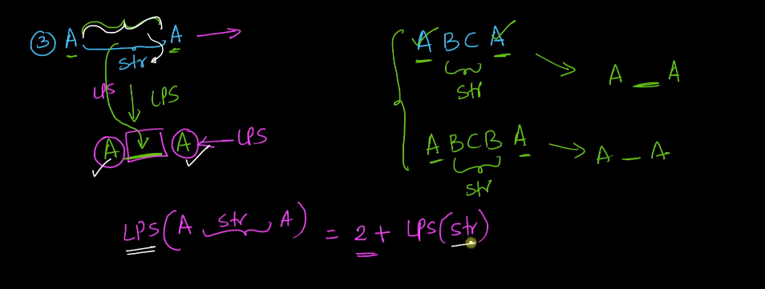

If first and last character match, then LPS is shown above. Here we are adding 2 because first and element are two elements which needs to be added in the length.

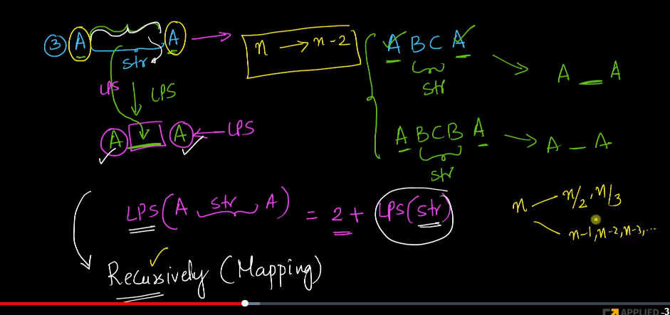

here we are modifiding the problem into n-2 recursive problem.

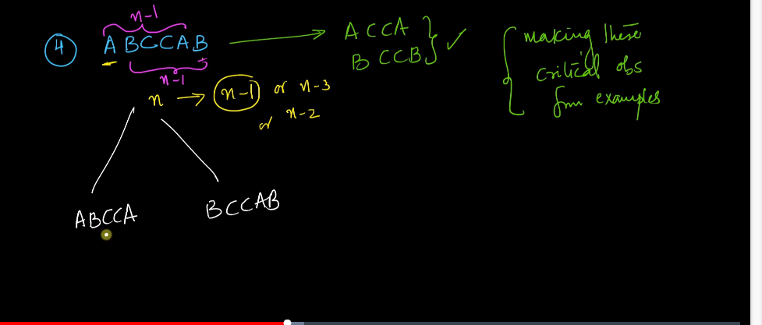

If first and last character is not matching, then we take the above approach to break the problem of n character into n-1 of character. Here we are considering the problem we are will consider first element and dont consider the last element or we will not consider the first element and consider the last element. Then we will need to take the maximum of it.

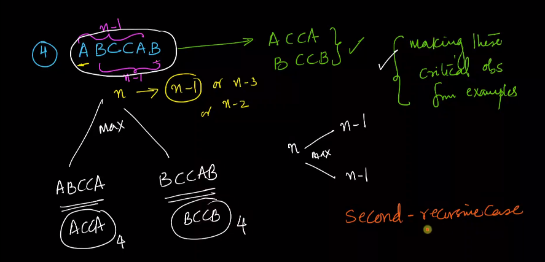

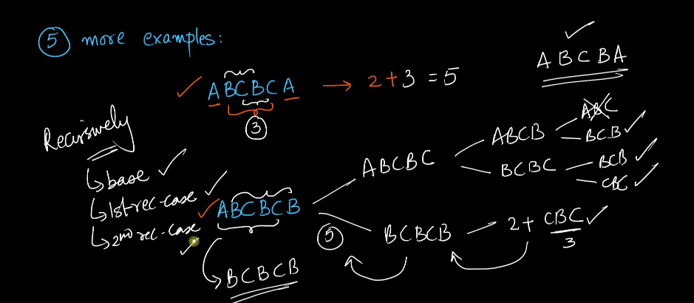

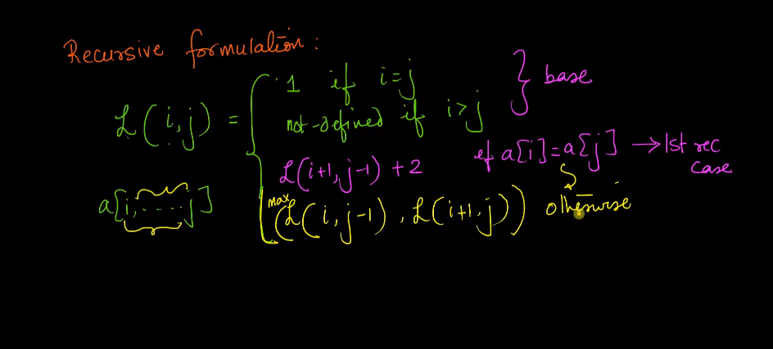

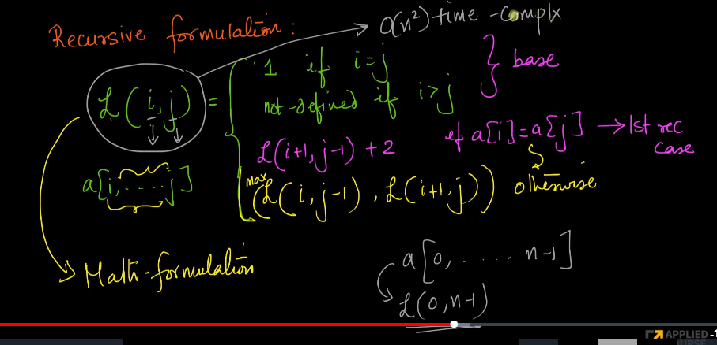

This formulation will take o(n2) time complexity itself.

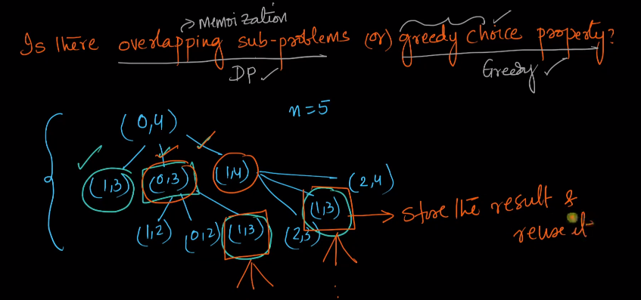

We can define the problem using dyamic progamming.

In DP, i can create an two dimensional array and reuse it multiple times

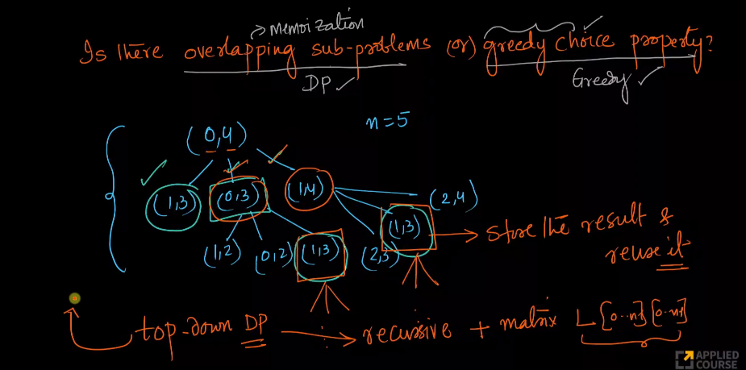

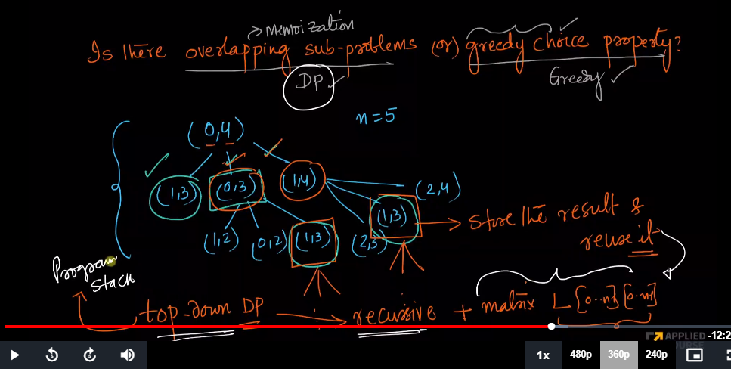

Here since it is recursion, there is program stack associated with it which will consume some memory in top down approach.

So instead of usiing spacre for program stack, we will bottom up approach which is iterative approach.

bottom up DP----> Iterative

top down Dp----> recursive DP

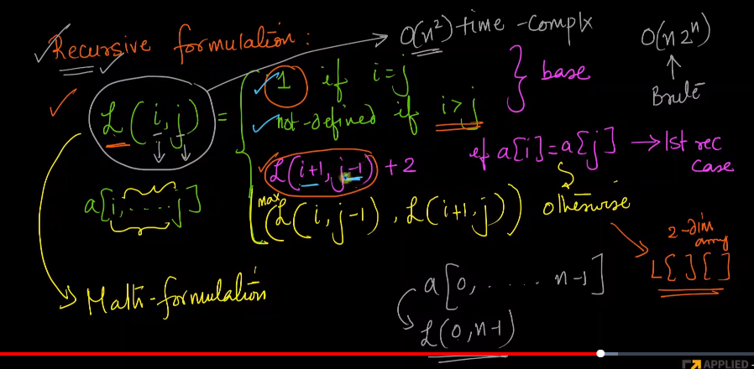

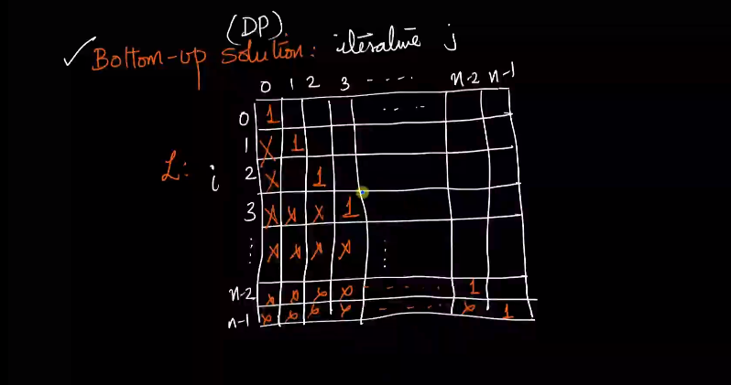

In the formulation, if i==j, it will be 1, So we have put 1 here, if i<j, it is not defined, then it will marked as X as we are considering it. So it will be upper triangular matrix here.

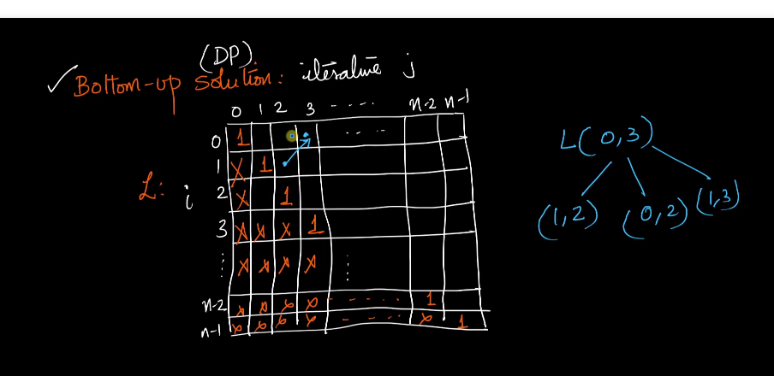

Here the solution of L(0,3) can come from either of the three cell as mentioned above based on our formulation.

Here we are filling the elements diagonally and the last element that we will be filling is L[0,n-1].

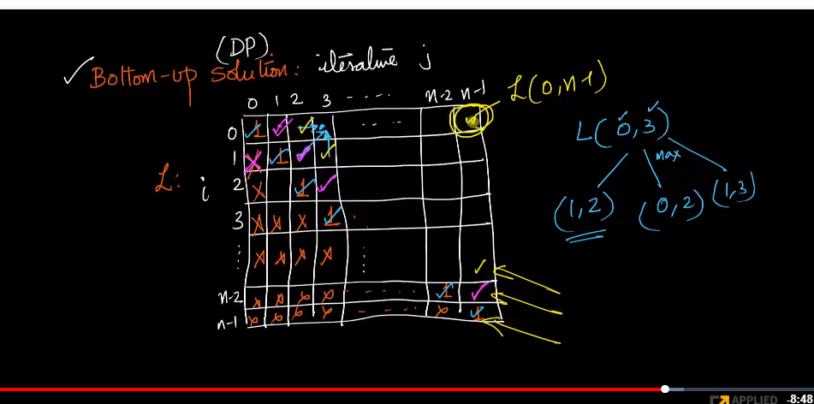

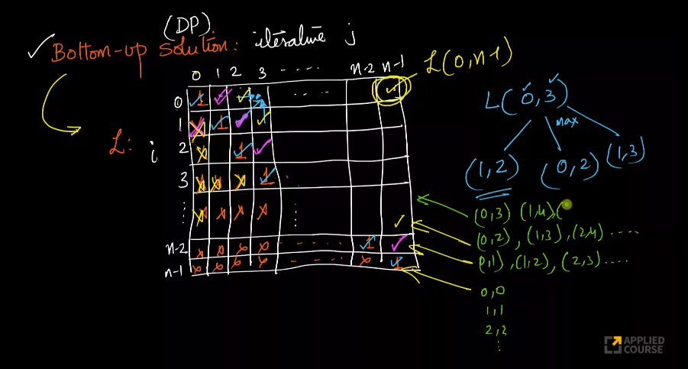

Here we are considering the diagoal element, If you see in the diagonal elements, first character are (0,0), then (0,1), then (0,2).Here we can see that the gap is increasing till we reach (0,n-1).

Also in first diganoal the gap is 1.For example, (0,1),(1,2) ..

for 2nd diagoal the gap is 2. for exmaple (0,2),(1,3) etc.

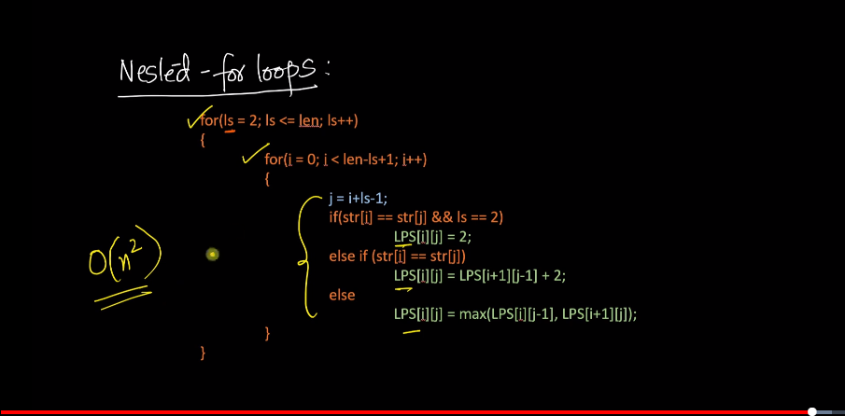

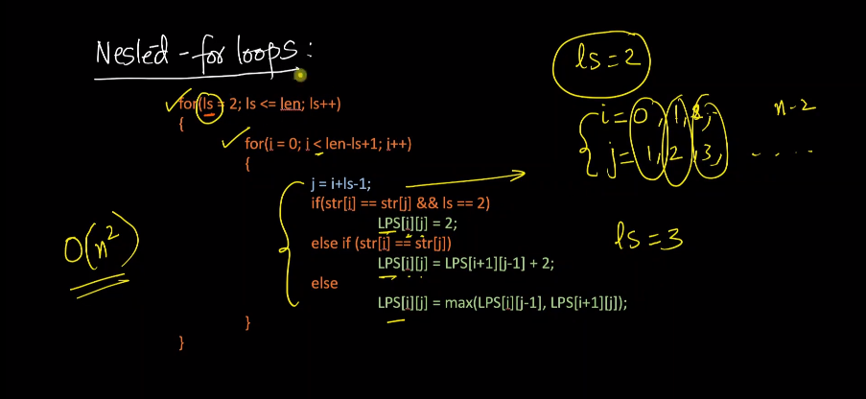

Here if ls=2, the gap between i and j is 1. when ls=3,the gap between i and j is 2.

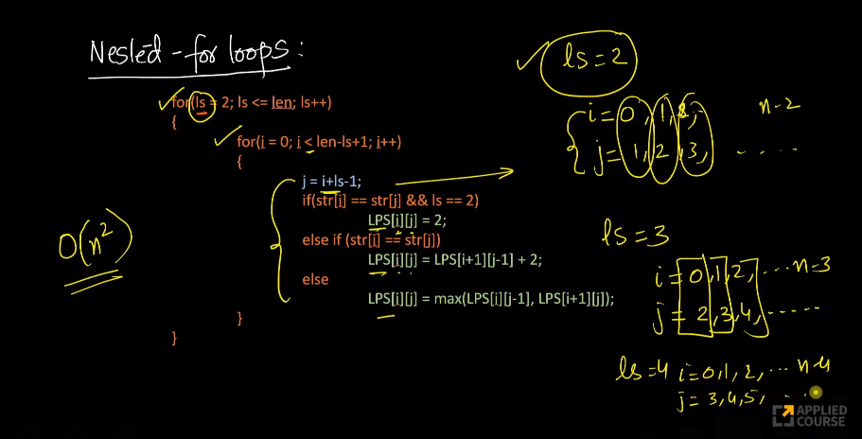

Python Code:-

#Bruteforce approach Recursive Approach

def longestPalindromicSubsequnce(s,i,j):

if i==j:

return 1

if s[i]==s[j] and i+1==j:

return 2

if s[i]==s[j]:

return longestPalindromicSubsequnce(s,i+1,j-1)

return max(longestPalindromicSubsequnce(s,i+1,j),longestPalindromicSubsequnce(s,i,j-1))

if __name__=='__main__':

s='AAIC'

n=len(s)

print(longestPalindromicSubsequnce(s,0,n-1))

#Dynamic Programing Approach

def longestPS(s):

n = len(s)

dp = [[0 for x in range(n)] for x in range(n)]

for i in range(n):

dp[i][i] = 1

for x in range(2, n+1):

for i in range(n-x+1):

j = i+x-1

if s[i] == s[j] and x == 2:

dp[i][j] = 2

elif s[i] == s[j]:

dp[i][j] = dp[i+1][j-1] + 2

else:

dp[i][j] = max(dp[i][j-1], dp[i+1][j]);

return dp[0][n-1]

if __name__=='__main__':

s='AAIC'

n=len(s)

print(longestPS(s))

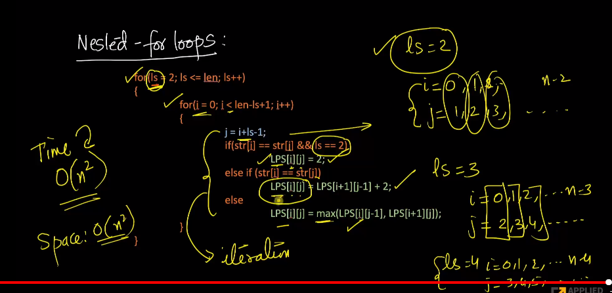

# climbing stairs problem

There are n stairs, a person standing at the bottom wants to reach the top. The person can climb either 1 stair or 2 stairs at a time. Count the number of ways, the person can reach the top.

[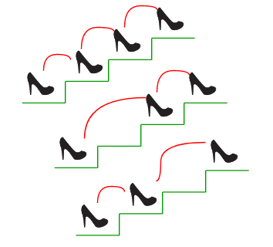](https://media.geeksforgeeks.org/wp-content/uploads/nth-stair.png)

Consider the example shown in the diagram. The value of n is 3. There are 3 ways to reach the top. The diagram is taken from [Easier Fibonacci puzzles](http://www.maths.surrey.ac.uk/hosted-sites/R.Knott/Fibonacci/fibpuzzles.html)

**Examples:**

**Input:** n = 1

**Output:** 1

There is only one way to climb 1 stair

**Input:** n = 2

**Output:** 2

There are two ways: (1, 1) and (2)

**Input:** n = 4

**Output:** 5

(1, 1, 1, 1), (1, 1, 2), (2, 1, 1), (1, 2, 1), (2, 2

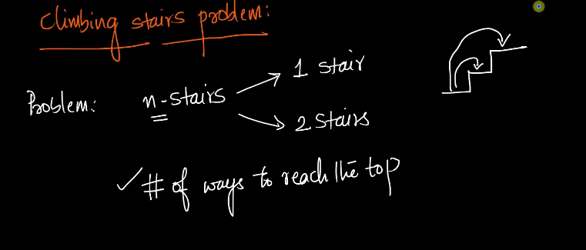

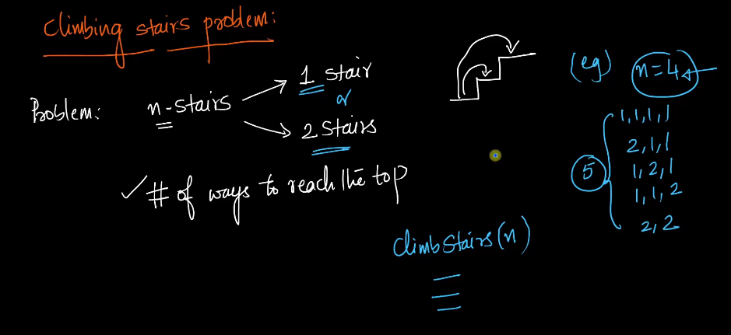

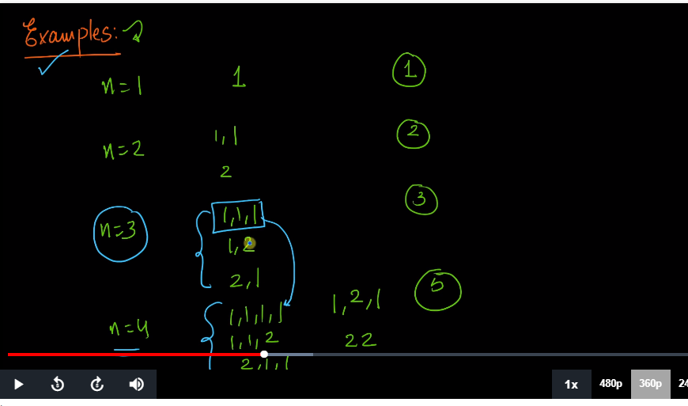

Can we arrive future values by using the previous example.

From n=3, if we can add 1 to each item we will arrive n=4.

1,1,1, if we add another 1 here we will arrive n=4.

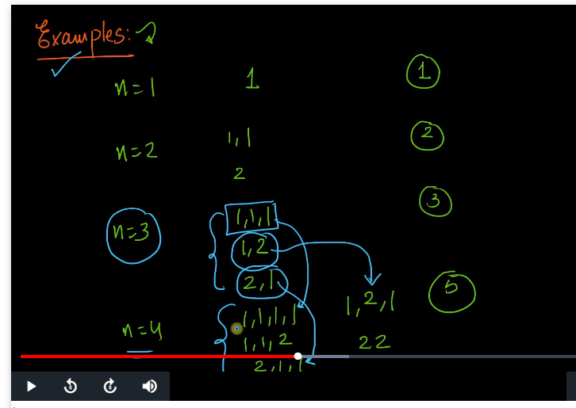

Out of 5 steps, we already got three by adding 1 to them.

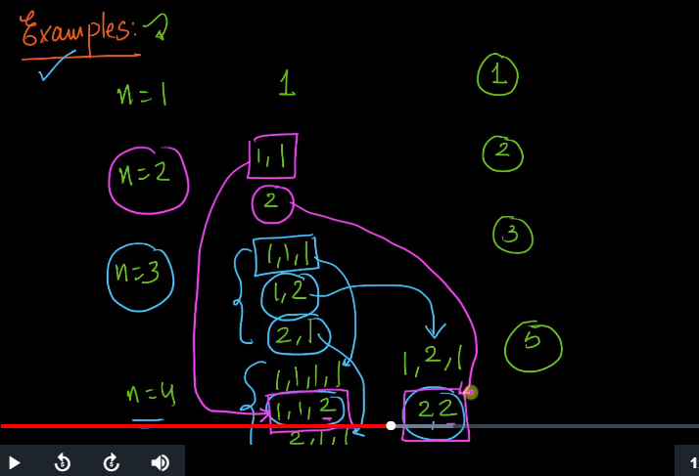

IF we can add two steps to n=2, then we will get another 2 outputs that we require.

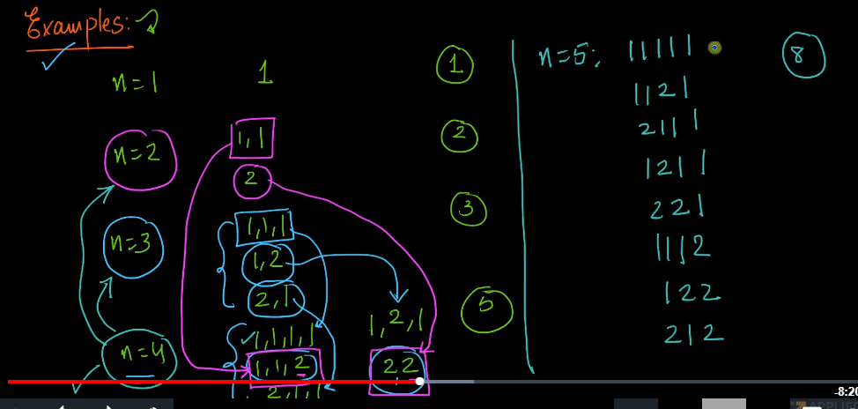

in n=5, we will get 8 possibilities which we are getting 1 to n=3 and 2 in n=3 output.

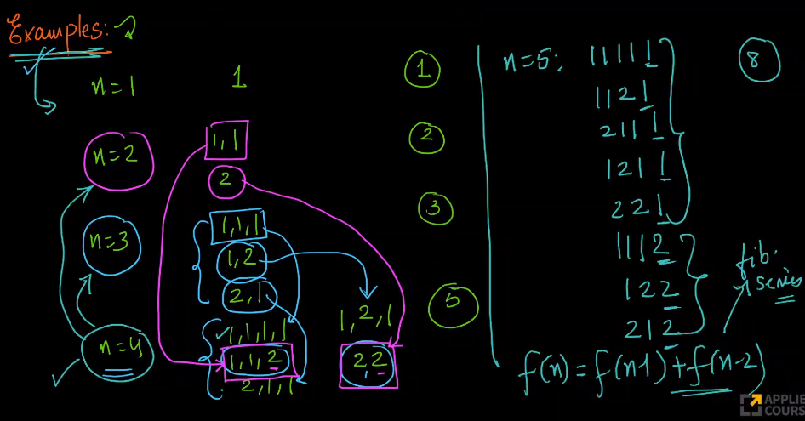

f(n-1) is the number of ways we climb the stair.

Here we are taking the count, not the actual number.

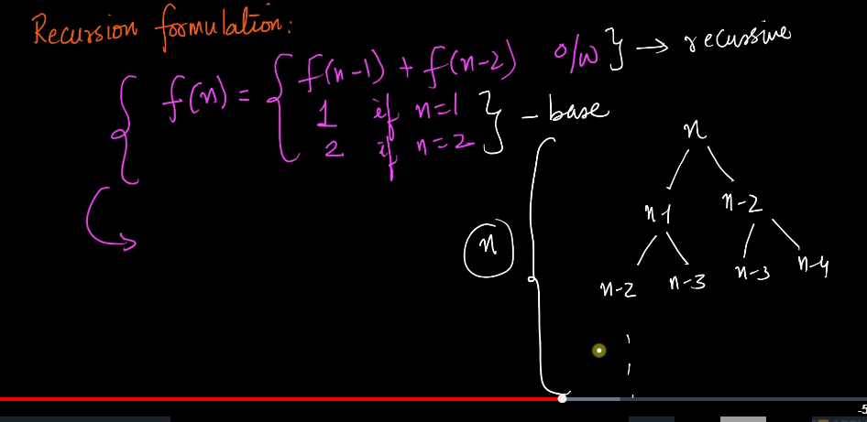

Height of the recursion tree is n.

The depth of the stack will be 0(n).

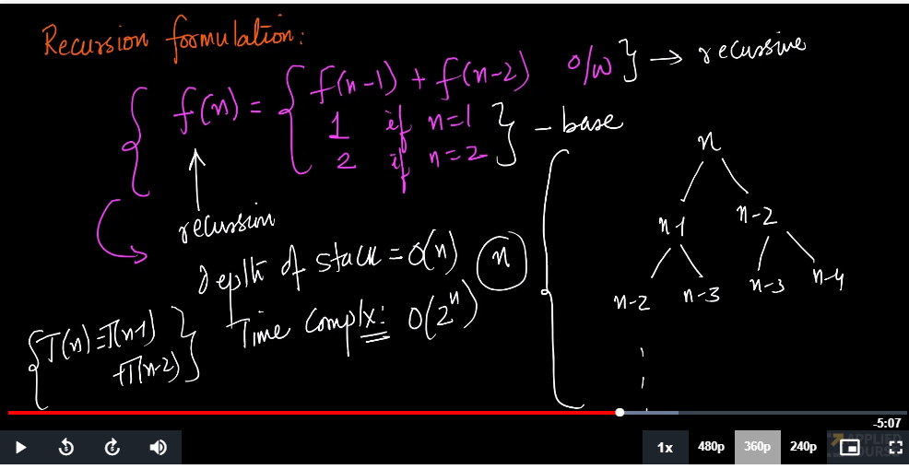

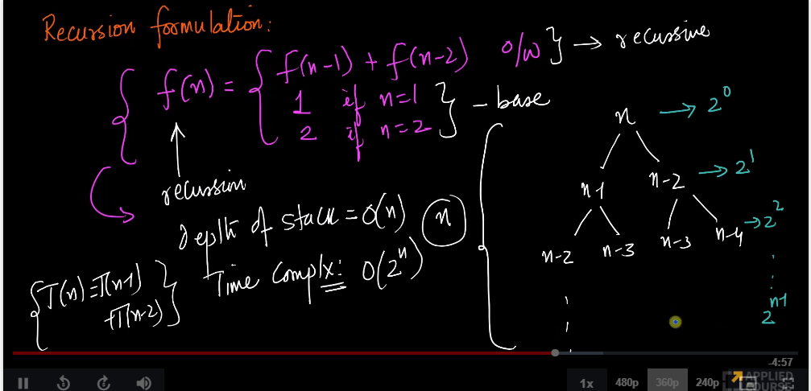

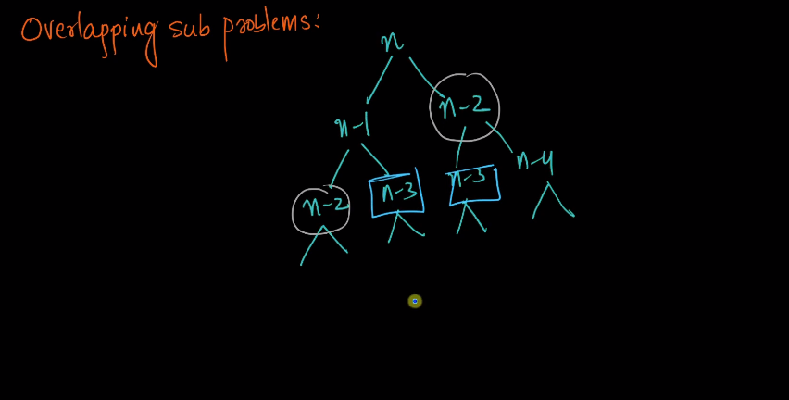

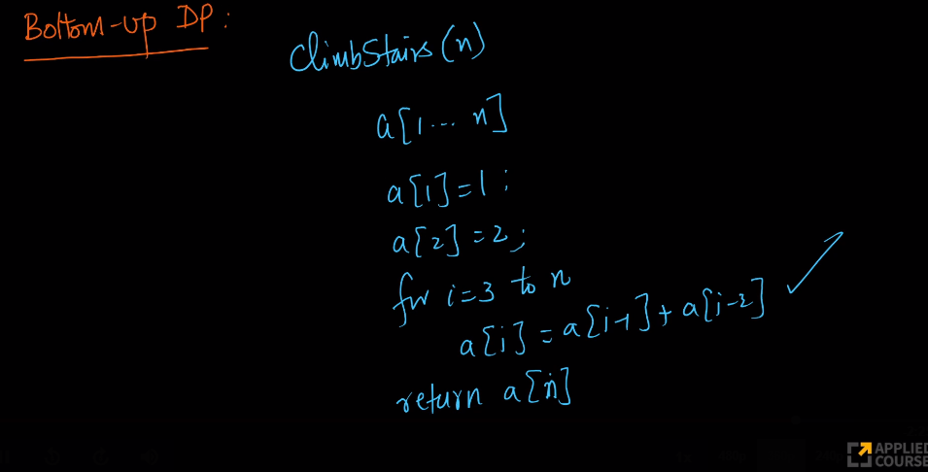

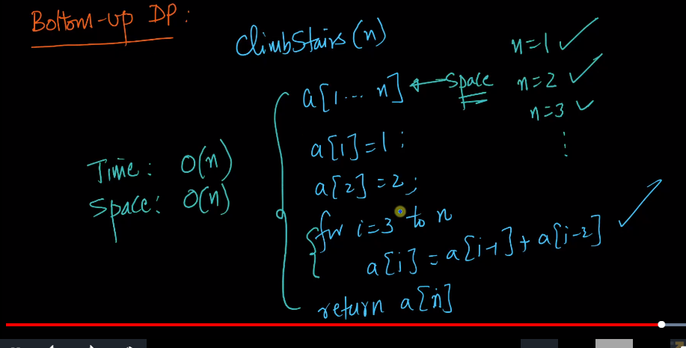

#recursive solution

def climb_stairs(i,n):

if i>n:

return 0

if i==n:

return 1

return climb_stairs(i+1,n)+climb_stairs(i+2,n)

if __name__=='__main__':

print("number of ways",climb_stairs(0,4))

#Dynamic Programming

def climbStairs(n):

if(n==1):

return 1

dp=[0 for i in range(n+1)]

dp[1]=1

dp[2]=2

for i in range(3,n+1):

dp[i]=dp[i-1]+dp[i-2]

return dp[n]

if __name__=='__main__':

print("number of ways",climbStairs(4))

# nth ugly number

Ugly numbers are numbers whose only prime factors are 2, 3 or 5. The sequence 1, 2, 3, 4, 5, 6, 8, 9, 10, 12, 15, … shows the first 11 ugly numbers. By convention, 1 is included.   
Given a number n, the task is to find n’th Ugly number.

**Examples:**

Input : n = 7

Output : 8

Input : n = 10

Output : 12

Input : n = 15

Output : 24

Input : n = 150

Output : 5832

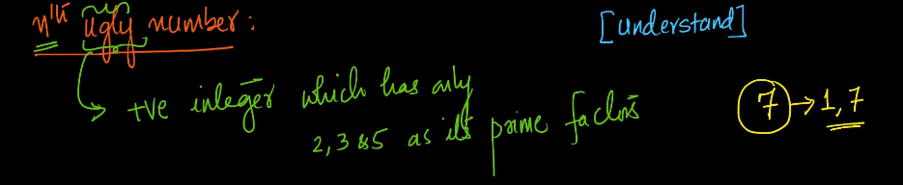

7th is not the ugly number

**1 is exception which is considered as Ugly number**

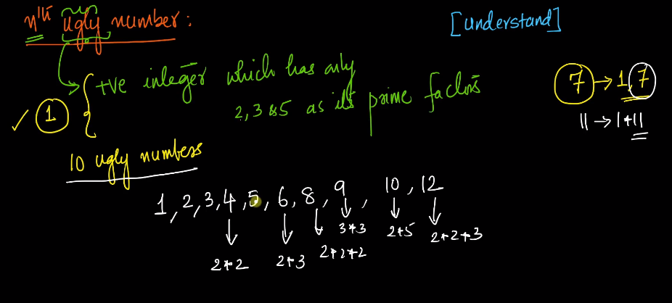

Top 10 ugly numbers are shown above which has only 2,3 or 5 as their prime factors.

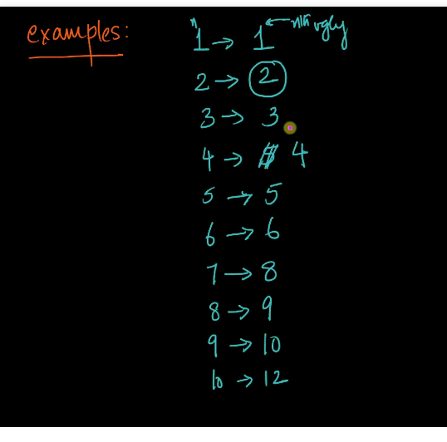

Top 10 ugly numbers are shown above.

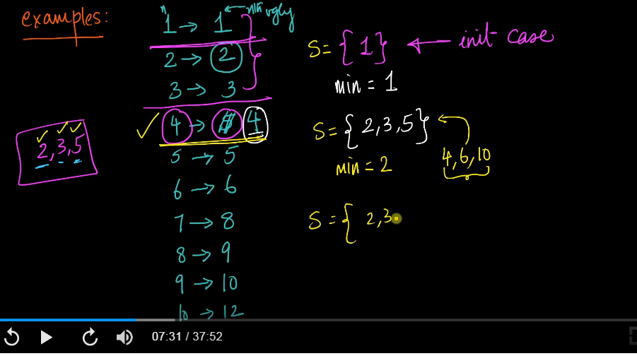

initially my set will contain only 1. After that we will multiply {2,3,5} to the set to get new set. After that we will take the minimum element and then multiply {2,3,5} in the set and so on.

Also from the set i will remove the minimum element.

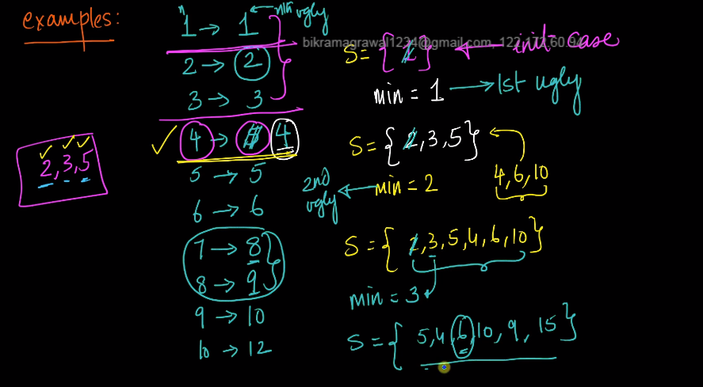

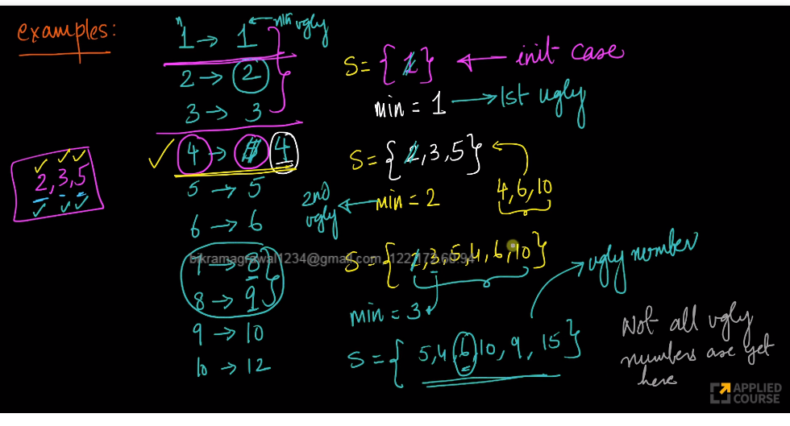

Here we can see that the ugly numbers are not in sequence. but surely we can see that the minimum numbers are ugly numbers. So we can expand the set to construct our logic.

Means min=2, is the ugly number. min=3 is the ugly number,

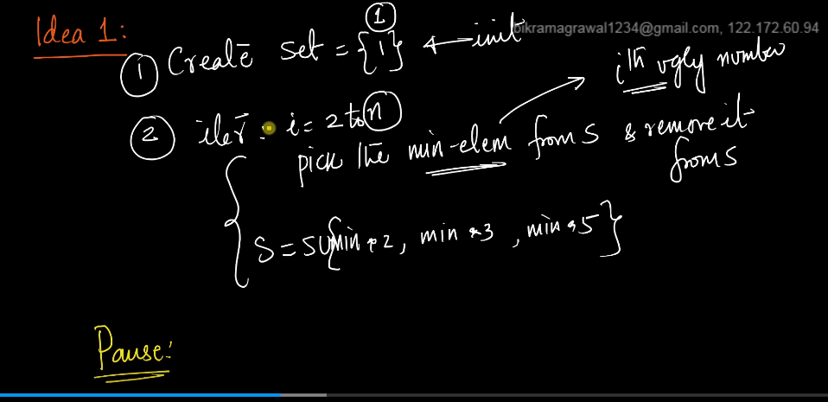

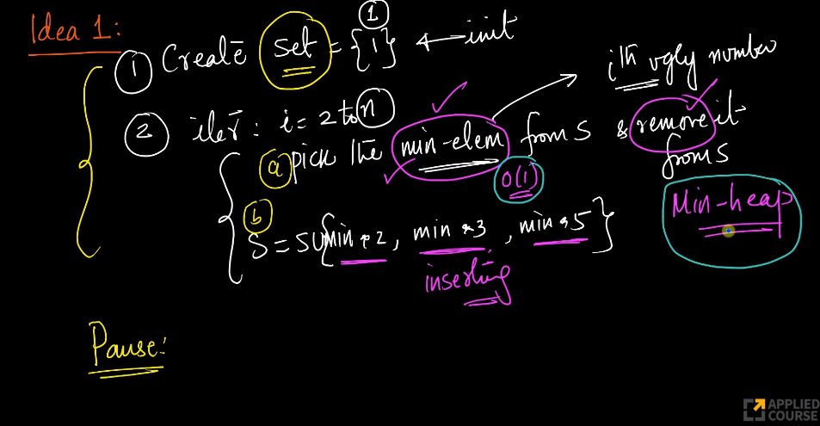

We can use min heap here as finding the minimum element will be order of 1.

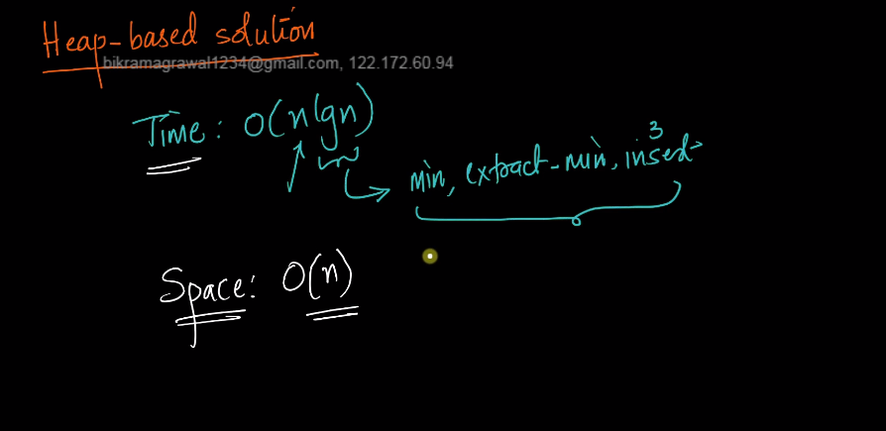

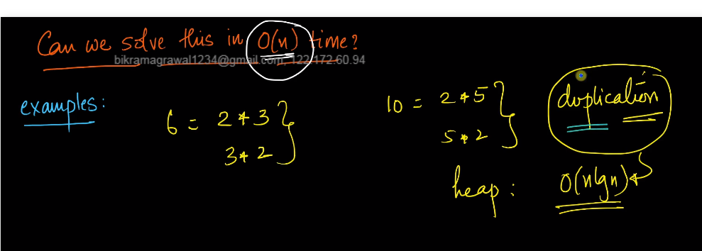

Here we are double computing lot of things here,

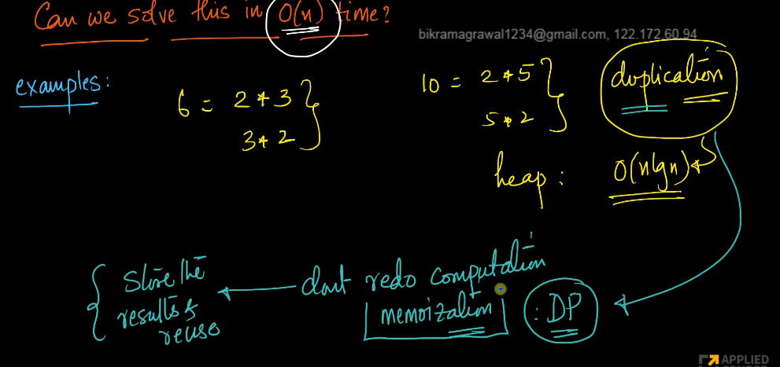

If we are doing memoziation, then we need to take array.

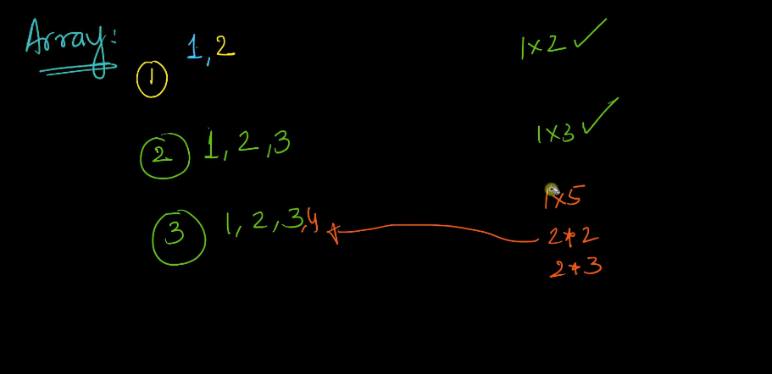

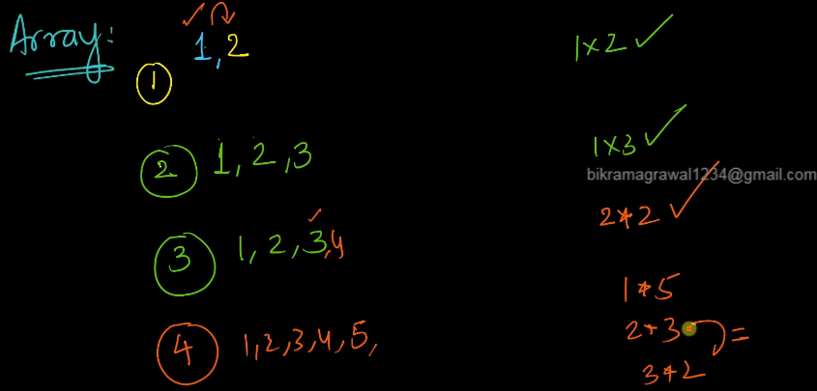

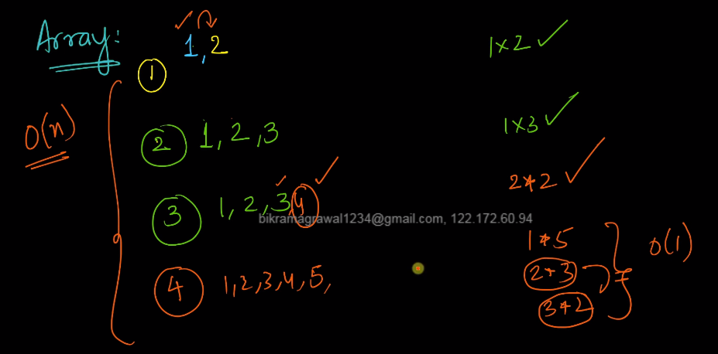

In the above screenshot, we are taking the minimum value out of all the multiplication.

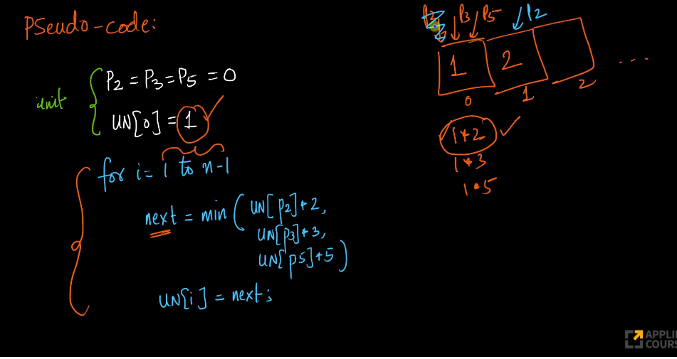

Here we need to track that 1*2 is already been done. So we need to move our pointer to index value 1 where value is 2.

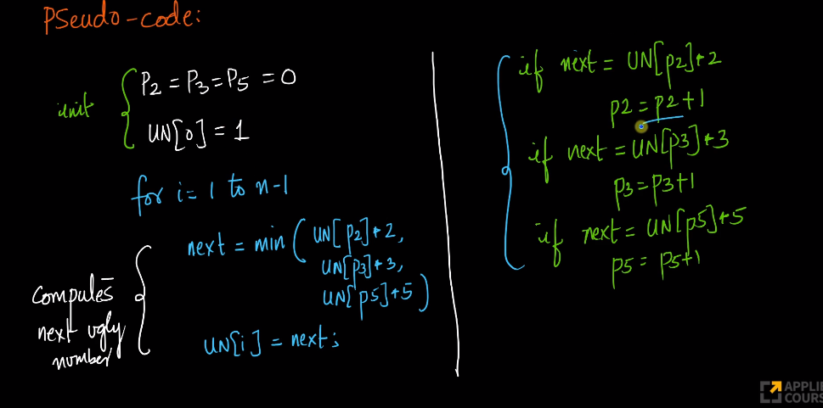

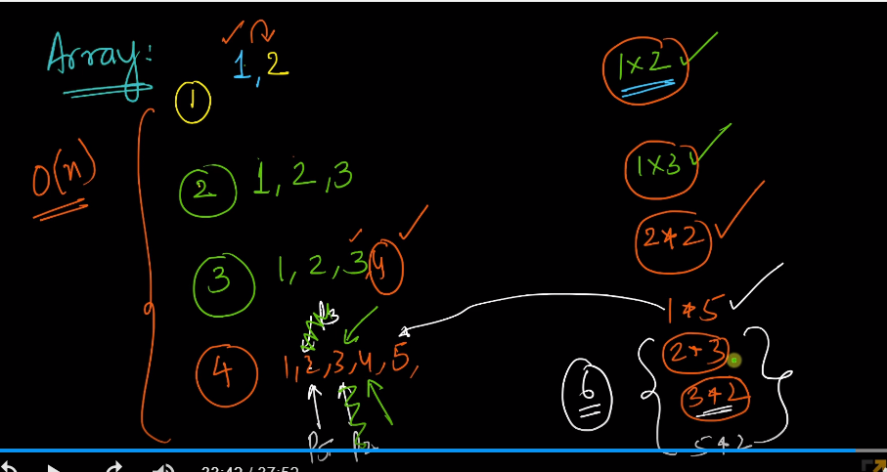

if multiplication is same for both the values, then our both the pointer will move.

Here we are inserting 6 only once. In heap case earlier, when we have to insert 6, we have to search in the heap whether 6 is present or not which takes 0(n) time.

